**Exposys Data lab**

**Topic Name :** **COVID SAHARA**

**Student Name :** **Sahil Vaidya.**

**Email-id :**  sahilvaidya7777@gmail.com

**CONTENTS**

Abstarct

Introduction

Existing Method

Proposed Method With Architecture

Methodology

Benefits

Implementation

Conclusion

**ABSTRACT**

We get easy availability of plasma to the person who is affected.

To reduce time of the person finding plasma .

Easy availability of plasma .

By viewing website can save time for finding plasma for patient.

**INTRODUCTION**

I am Sahil Vaidya, first of all you know that what kind of

situation we are suffering from .

Our government and health department of India is dealing good with this Covid-19 Pandemic, but on the ground field something is not getting good.

So by seeing this condition I decided solve it in my project.

**EXISTING METHOD**

By seeing this critical situation my objective is to get easy availability of plasma to the person who is affected by corona virus .

And also as this web based application is only limited for the College Students.

My aim is to reach maximum people in the state and the country.

**PROPOSED METHOD WITH**

**ARCHITECTURE**

To reduce time of the person finding plasma .

Person can reach the plasma donor by there information .

Corona positive person can get fast medical treatment .

And the person will not panic or frustrate to find the plasma .

**METHODOLOGY**

In this project student has to register .

When he/she is register they can view their profile by login .

Admin can also login to their profile and can see many options .

Admin can view the details of students by their own login .

**How it will be use?**

When the web based application is hosted ,  
 students and admin can visit site, by putting

WWW.COVIDSAHARA.COM in

their url and can able to see home page of website.

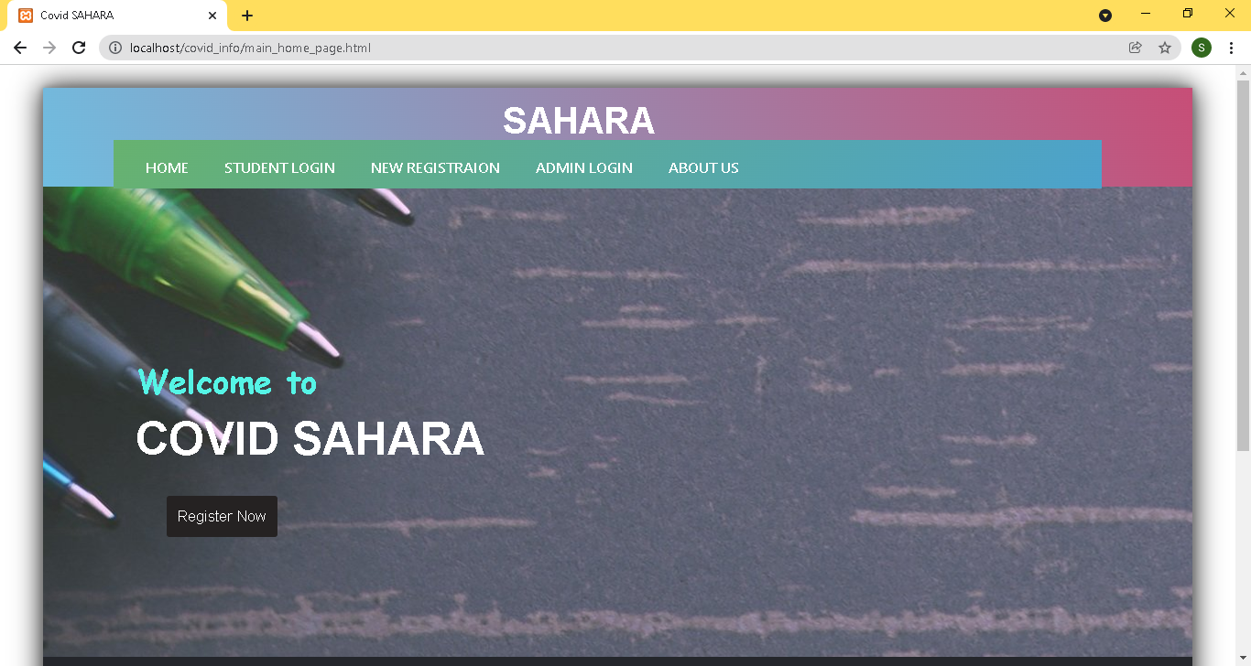

Student have to click on the REGISTRATION link.  
when they click on registration link they are directed to STUDENT REGISTRATION PAGE .

After that they have to fill the necessary details such as personal information and create their own login id .

And press on the SUBMIT button.

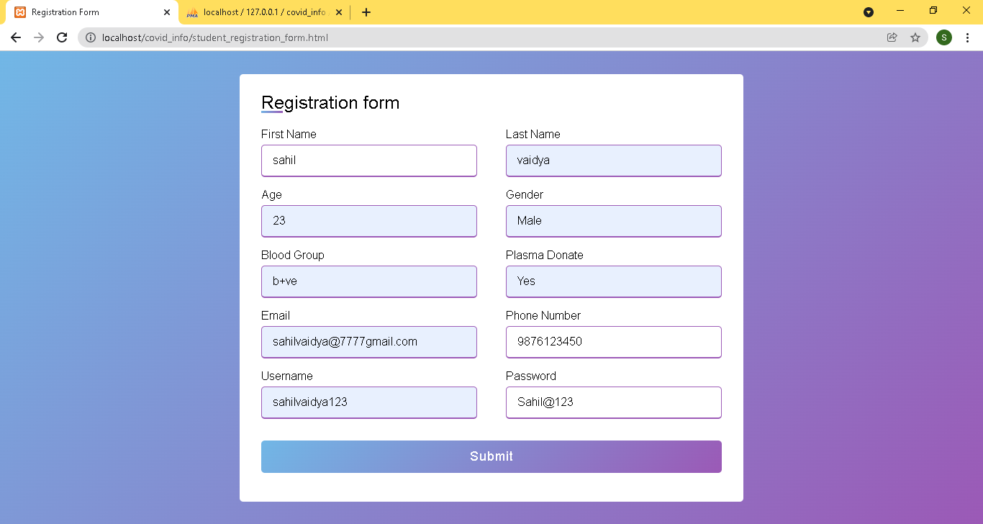

After clicking on the SUBMIT BUTTON.  
the registration details of students are stored inside the DATABASE.

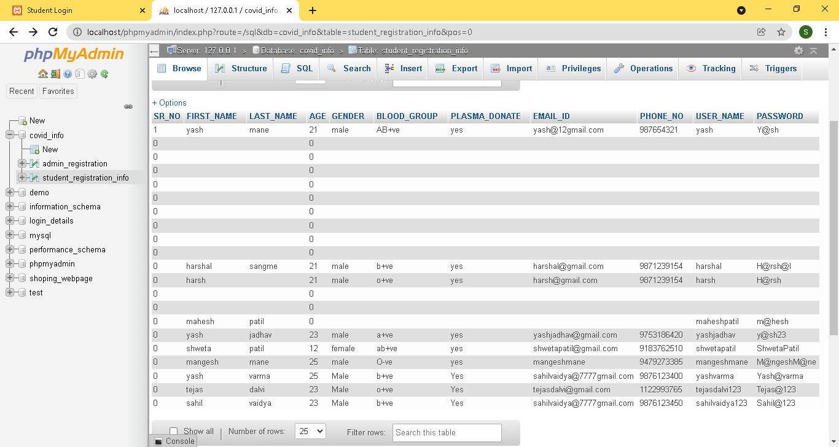

After successful registration students are  
able to LOGIN themselves.  
When students goes to LOGIN PAGE they can put there Username and Password.

And press on the LOGIN button.

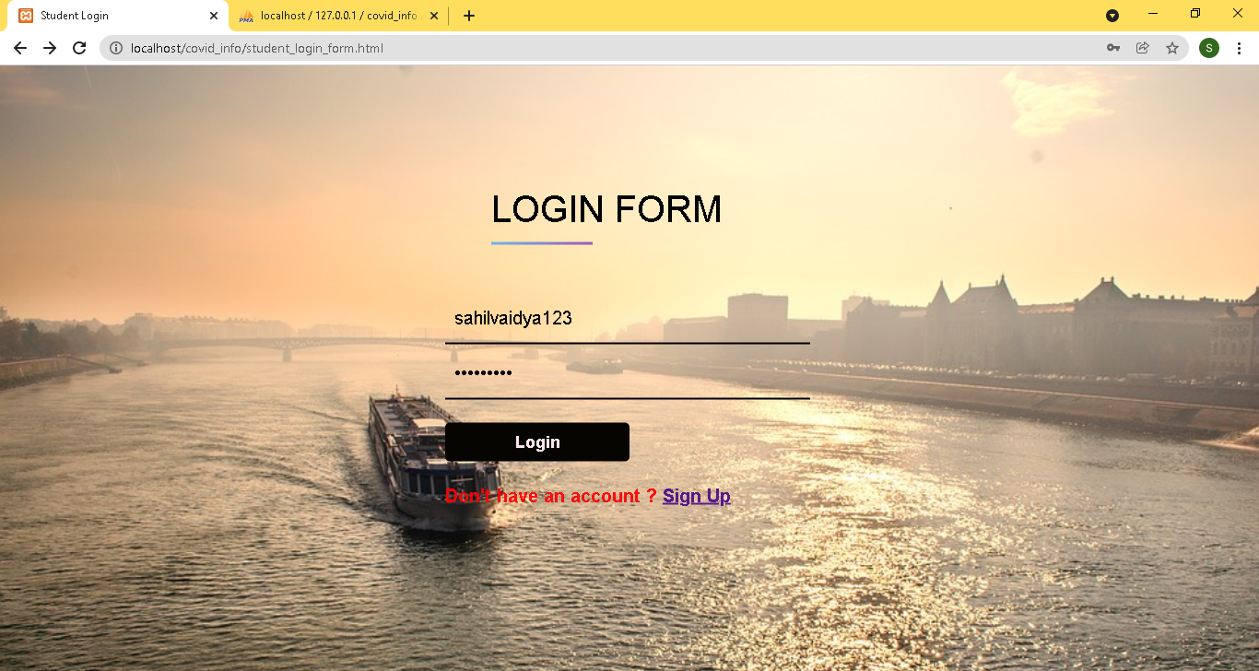

After clicking on the LOGIN button,  
the AUTHENTICATION of student is done in the backend by checking their Username and Password of student . if the entered details is true they are directed to STUDENT HOME PAGE .

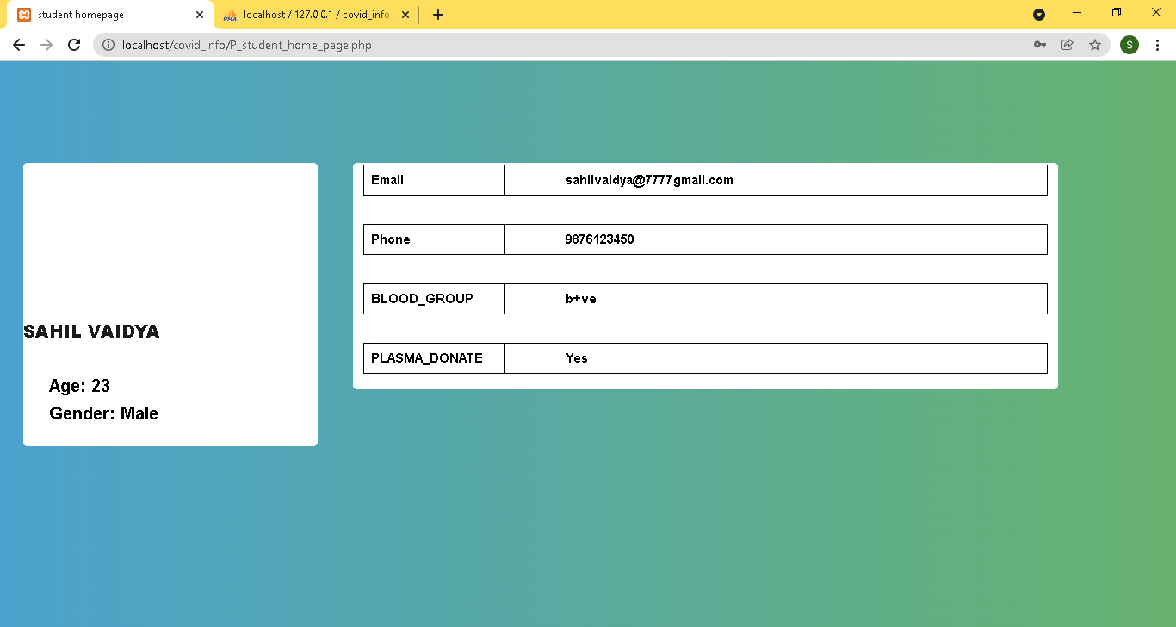

To logout from the student profile you can use   
 LOGOUT BUTTON.   
By clicking on LOGOUT BUTTON you are redirected to the STUDENT LOGIN PAGE.



Now after all the functions of students, we come across ADMIN FUNCTIONS .

First of all when the admin or teacher visits our site namely WWW.COVIDSAHARA.COM

They can see Homepage of our site .

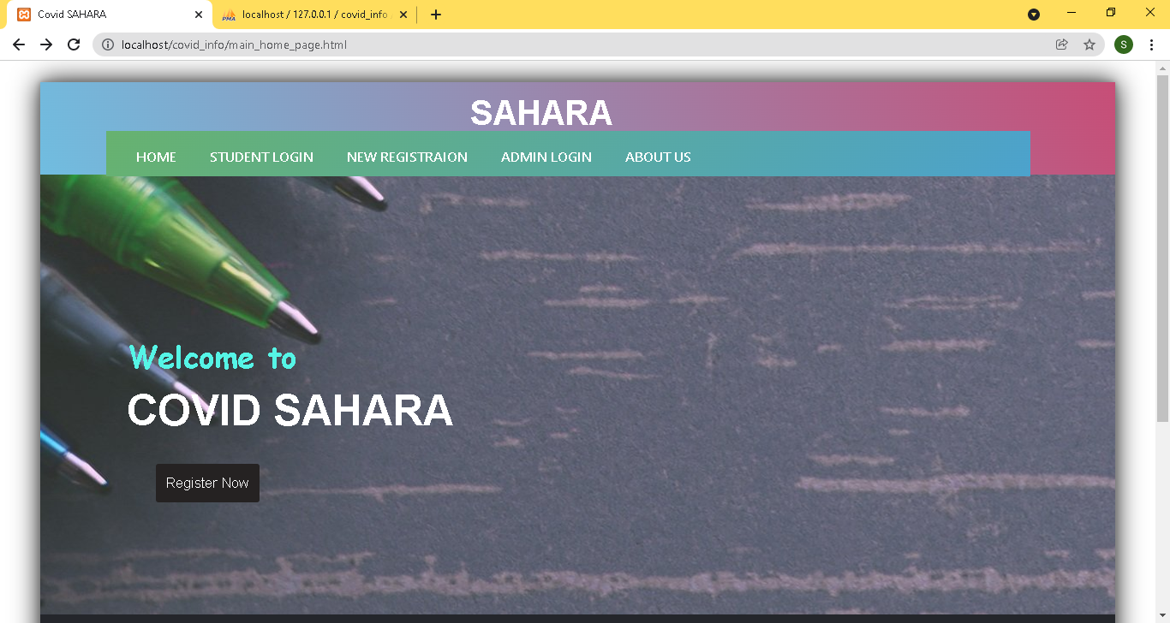

Teachers have to click on the ADMIN LOGIN BUTTON .

When they click on ADMIN LOGIN BUTTON they are directed to ADMIN LOGIN PAGE.

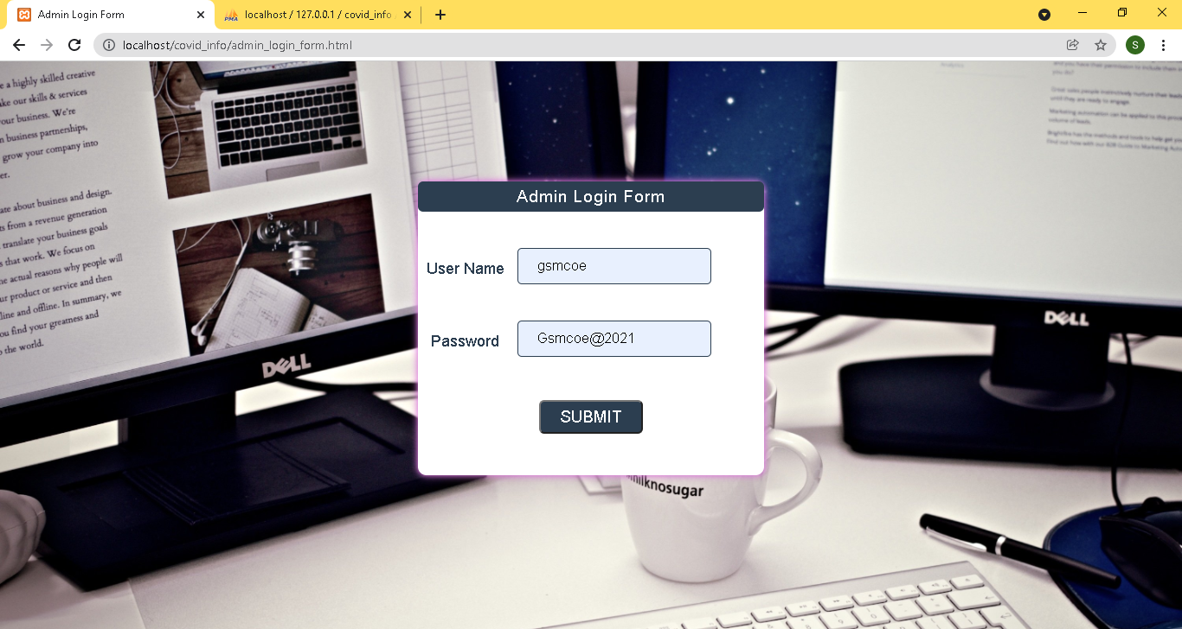

After clicking on the LOGIN button,  
the AUTHENTICATION of Admin or Teacher is done in the backend by checking their Username and Password of Admin .

If the entered details is true they are directed to ADMIN PORTAL PAGE .

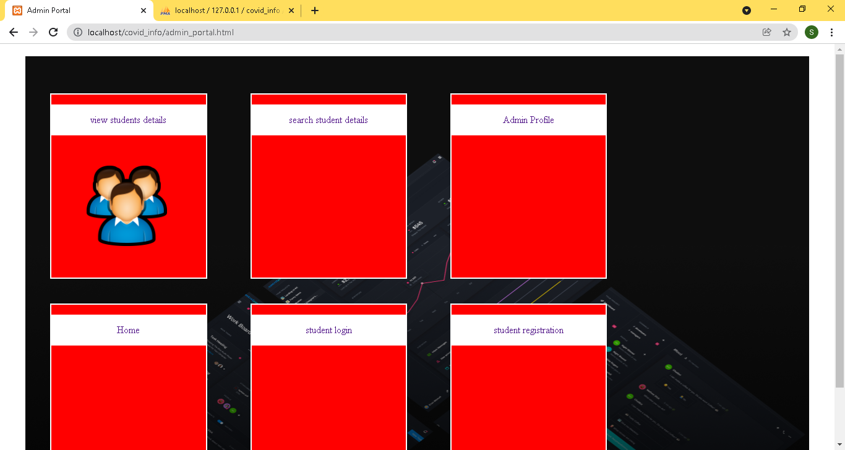

When they are directed to ADMIN PORTAL PAGE   
Teachers or admin can see many options for operations

As by clicking on first option namely VIEW STUDENT DETAILS, Teachers can able to see details of students in tabular format

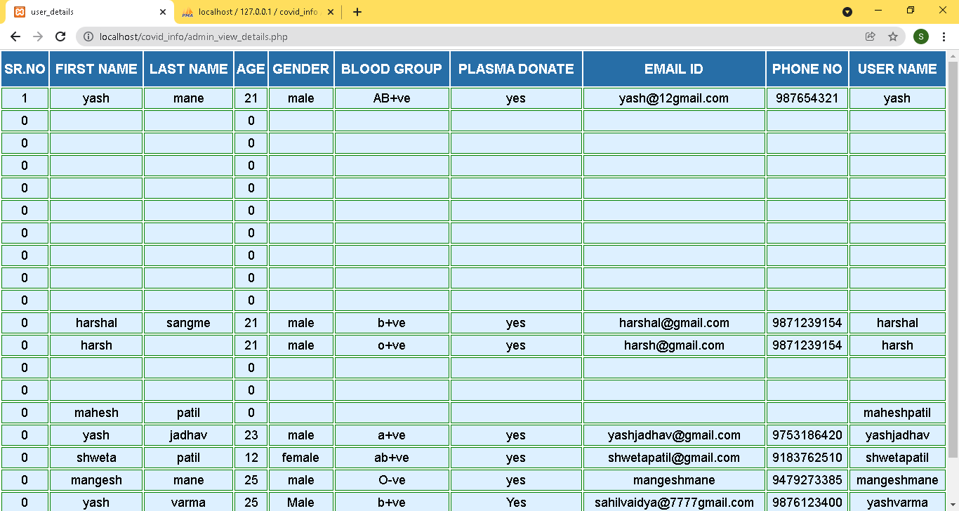

To logout from the Admin portal just click on  
 LOGOUT BUTTON.   
After that you are you can go into homepage of COVID SAHARA.

To check our information Just click on. About Us Button.

After that you will see Our About Us page.

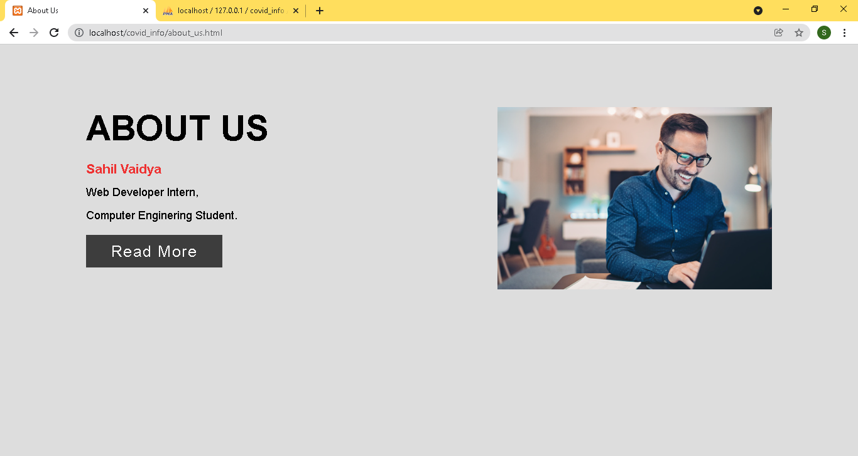

**Benifits:-**

Easy availability of plasma .

By viewing website can save time for finding plasma for patient.

There is no need to travel here and there .

As there is no travel, wastage of fuel and resources are reduce do which we can avoid pollution.

**Implementation:-**

Implementation of this project are developed using Programming Language.

I used languages like HTML & CSS.

**Conclusion:-**

Technology is make our life easier.

As patient is getting plasma soon, he/she will get recover soon.